**How to create a CryptoCurrency**

**1.)Visit:** [**https://remix.ethereum.org/**](https://remix.ethereum.org/) **and create a workspace and create a new file   
 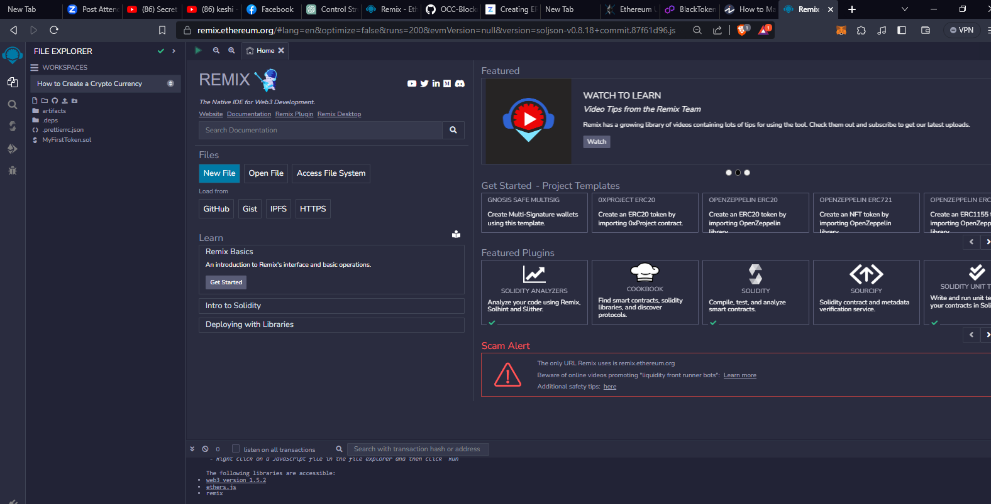** 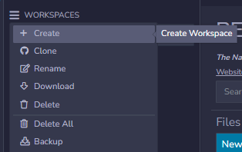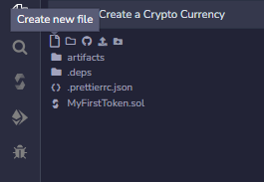

**2.) Import this codes/library into your file :**

**For reference you can visit :** [**https://docs.openzeppelin.com/**](https://docs.openzeppelin.com/)

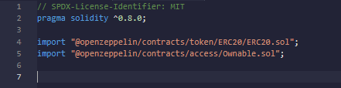

**ERC20.sol: This contract provides a standard implementation of the ERC-20 token standard, commonly used for creating fungible tokens on the Ethereum blockchain.**

**Ownable.sol: This contract provides access control mechanisms, allowing you to designate an "owner" with special privileges within your smart contract**

**By importing these contracts, you can use ERC-20 functionality for tokens and implement access control for your smart contract.**

**3.)Proceed to make a contract and functions** 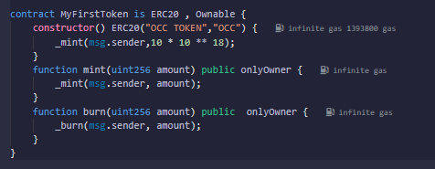

**MyFirstToken -it creates a new ERC-20 token with the name "OCC TOKEN" and the symbol "OCC."**

**mint - function allows the owner of the contract to create and add a specific amount of tokens to their own balance.**

**Burn - function with a specific amount, it will reduce their own token balance by that amount, effectively destroying (burning) those tokens.**

**4.) Log-in on your MetaMask Change your environment to Injected Provider -Metamask**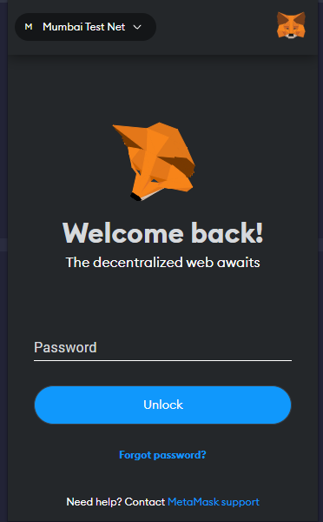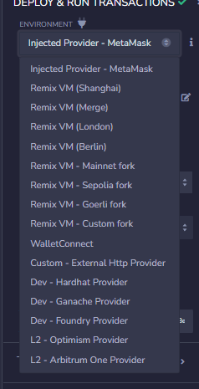

**5.When you click deploy (MetaMask will pop up (click Confirm )).**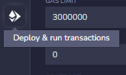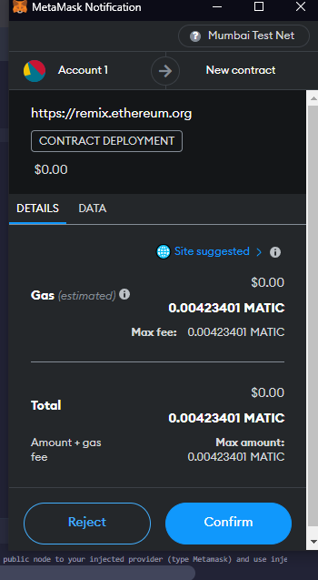

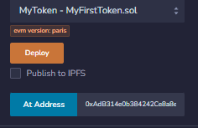

**6.It is advisable to check all of your functions and transactions to know if your contract is working.**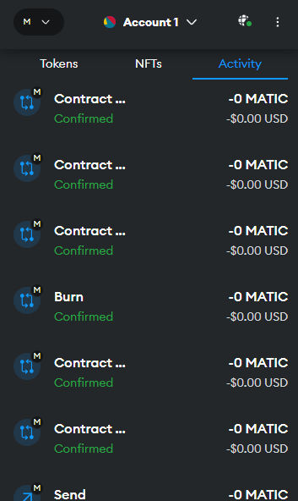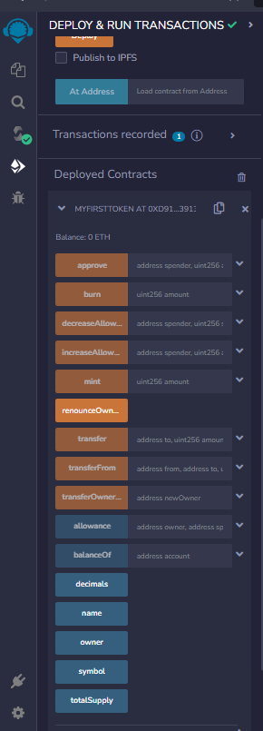

**8.) to check your transaction you can visit this website** [**https://mumbai.polygonscan.com/**](https://mumbai.polygonscan.com/)

**Copy your address : Paste it to Search bar** 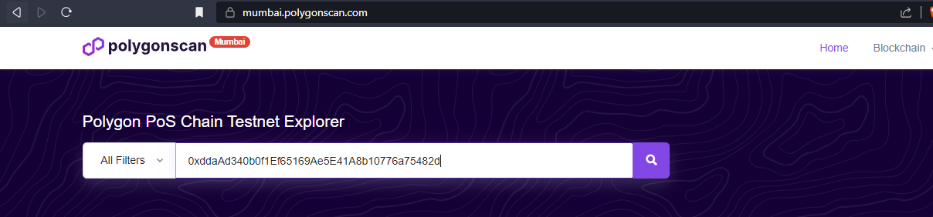

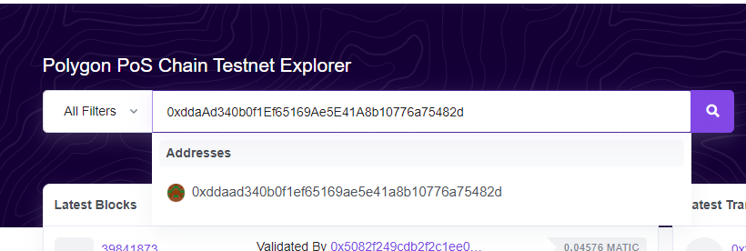

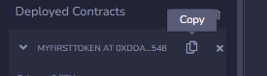

**7.)Click OCC TOKEN (OCC)**



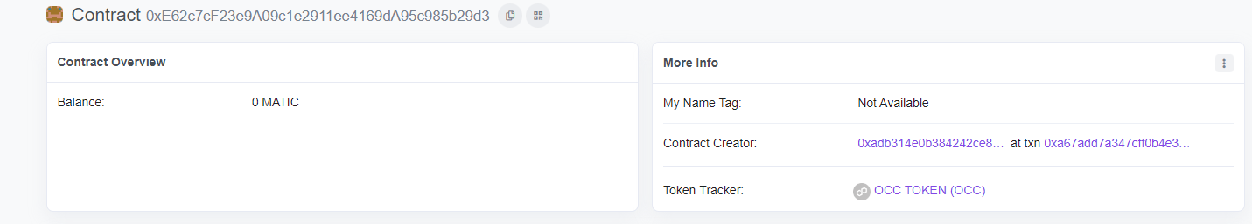

**8.) And that’s it , Congratulations for creating your own CryptoCurrency**

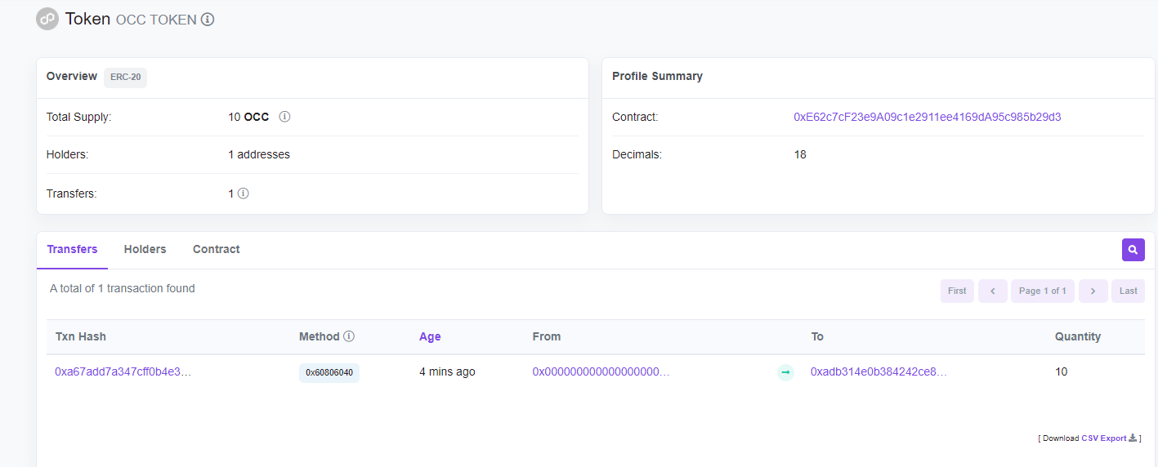

**To add value to your CryptoCurrency :**

**Open your metamask account :   
 Click the Expand view :**

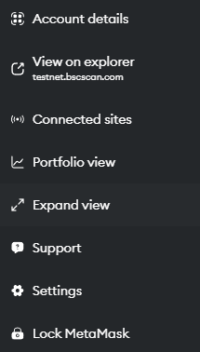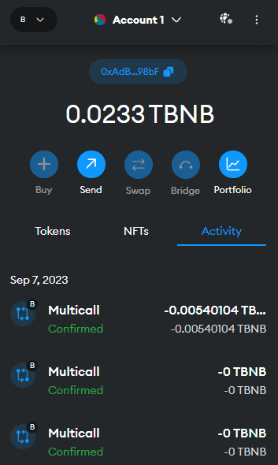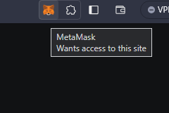

**2.)You will be redirected to the corresponding website upon clicking the 'Expand View' option.**

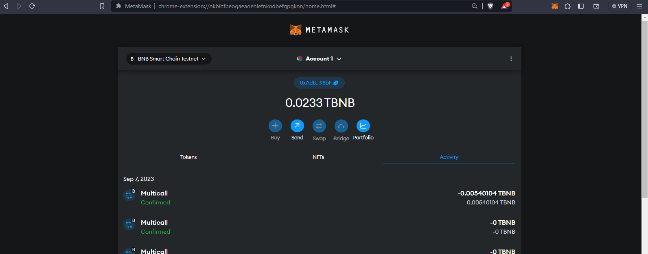

**.**

**3.) click and Select add Network** 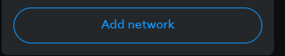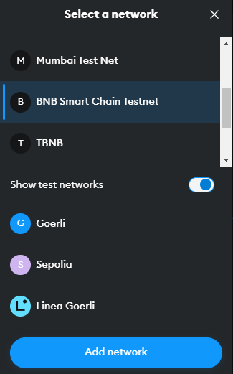

**4) visit this website** [**https://chainlist.org/**](https://chainlist.org/) **and search for tbnb:  
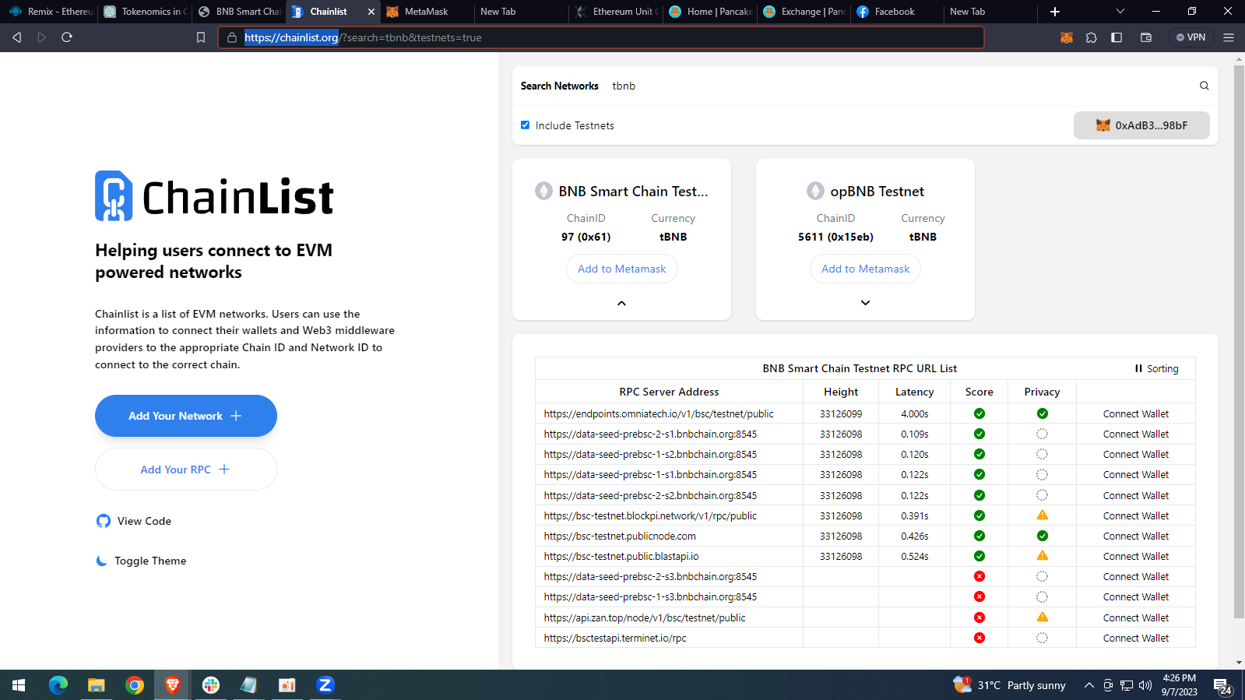**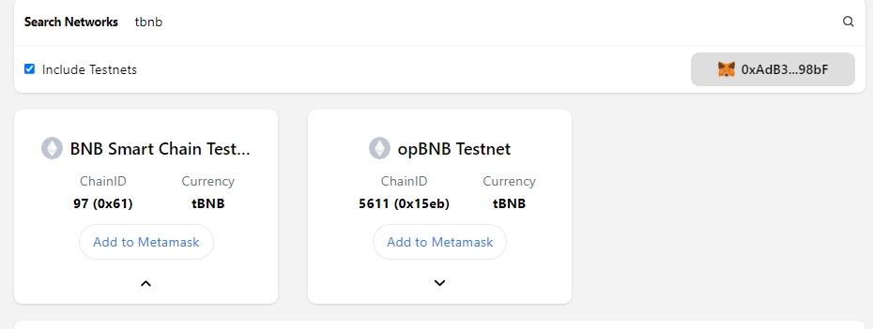

**5. Choose or click BNB with id 97**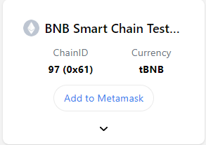

**6.Copy any address that you want :**

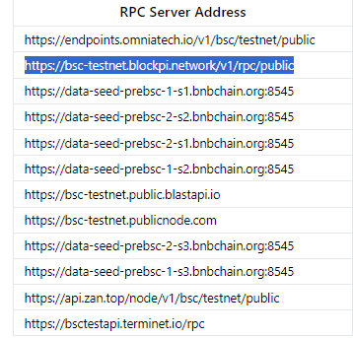

**.**

**7.) On your Metamask . Click on add a network manually :**

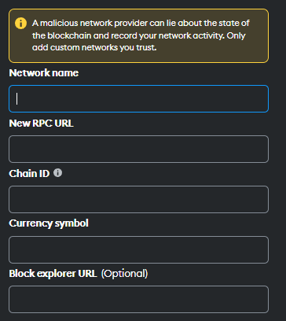

**8.Add all the information needed and click save**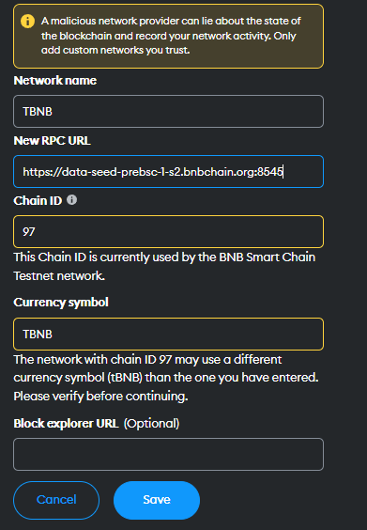

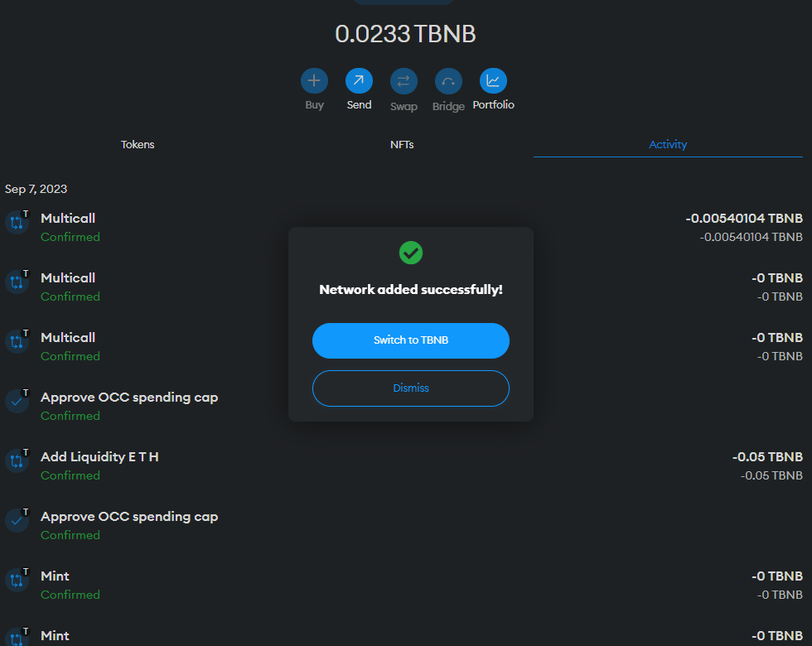

**9. Click on switch TBNB**

**10. Visit this website to** [**https://pancakeswap.finance/?chain=bscTestnet**](https://pancakeswap.finance/?chain=bscTestnet)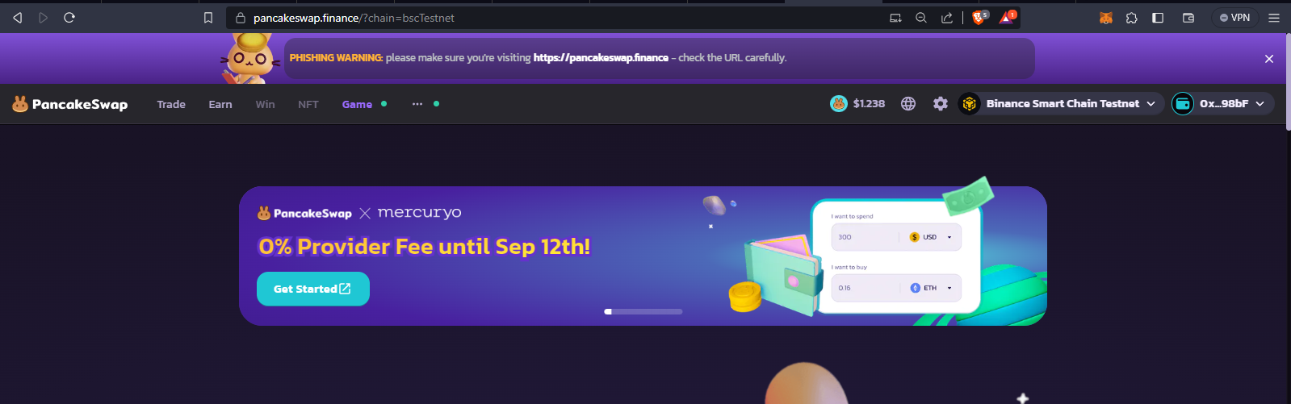

**11.)Hover your mouse on trade and click liquidity :**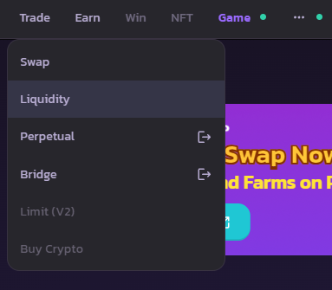

**12.) Change all to v2 and Click add liquidity:**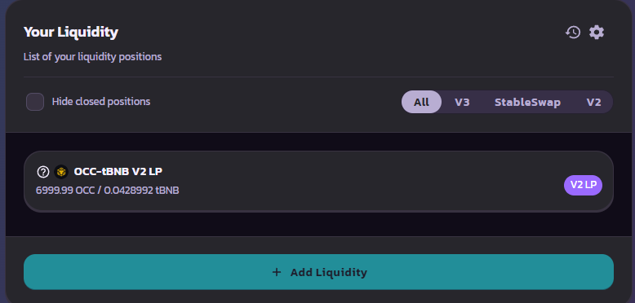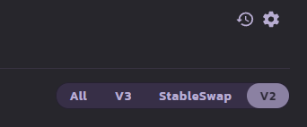

**13.) Import your token: And change Cake to OCC**

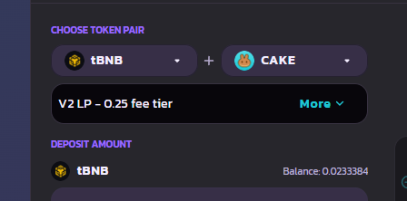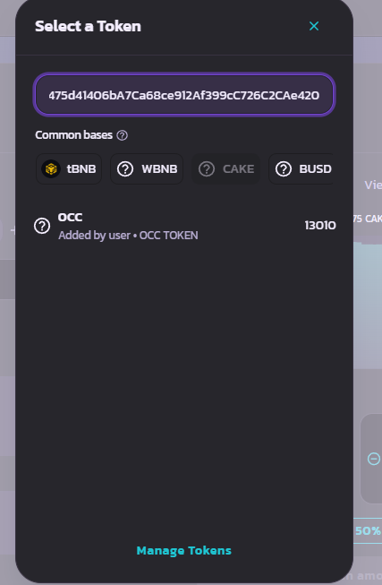

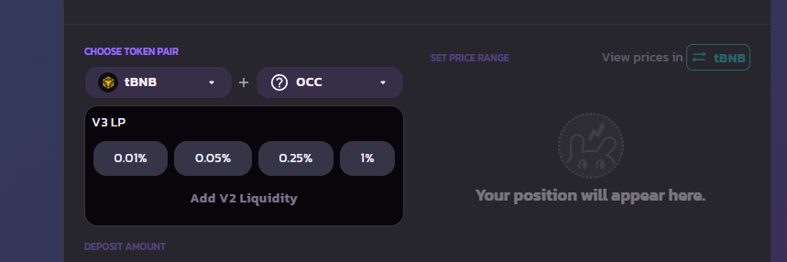

**13.You can now convert any amount you From OCC to TBNB:**

**And Go ahead and change your newly Created CryptoCurrency 👍👍:**